A New Aged Care Act: the foundations
  - Consultation paper No. 1
Contents

Introduction 6
Consultation 8
Proposed structure, purpose and constitutional foundation for the new Act 10
Proposed structure and purpose of the new Act 10
Proposed Objects of the new Act 11
Proposed purpose of the new Act 11
Proposed constitutional foundation for the new Act 12
What is new and what is different in the new Aged Care Act? 12
Additional resources 14
The Statement of Rights 15
A Statement of Rights as a centrepiece of the new Act 15
Which rights should be included? 16
How will rights be upheld under the new Act? 17
A rights-based approach 18
Additional resources 20
Statement of principles 21
The role of the Statement of Principles 21
Which principles should be included? 22
Additional resources 25
Definition of high quality care 26
Why define high quality care? 26
High quality care definition 26
Achieving high quality care 27
Additional resources 28
A new duty of care and compensation pathways 29
A new statutory duty on registered providers 29
Duties on other individuals and entities 30
Penalties 32
New compensation pathway 32
Additional resources 34
Disclosure protections for whistleblowers 35
Current Arrangements 35
Proposed changes 35
What protections will be made available? 37
Confidentiality of Whistleblowers 37
Obligations of Aged Care Providers 38
Additional resources 38
Supported decision-making arrangements 39
Existing arrangements for aged care 39
Interaction with other Commonwealth Laws 40
Interaction with State and Territory Laws 40
Criteria for appointment 41
Role of a supporter 42
Role of a representative 42
Supported decision-making principles and duties 43
Additional resources 44
Eligibility for funded Aged Care Services 46
Overview of current eligibility requirements 46
Issues with current arrangements 47
A simpler and fairer approach for accessing aged care 48
Proposed access and eligibility arrangements under the new Aged Care Act 48
Threshold eligibility test 49
Additional resources 51
Appendix A 52
Glossary of terms 52

Introduction
The Royal Commission into Aged Care Quality and Safety (the Royal Commission) recommended that a completely new Aged Care Act be developed. This paper aims to guide consultation on the proposed foundations of a new Aged Care Act (the new Act), which is currently under development.
“To achieve the fundamental reforms that we envisage for older people’s needs, and wellbeing to come first, a new Act is required.”
This paper complements existing consultation documents, which outline new policy initiatives that will be delivered via the new Act. It details some of the main foundational elements of the new Act for your consideration.
Your feedback will inform the Exposure Draft of the Bill for a new Aged Care Act, which is expected to be released for public consultation later in 2023. The Department of Health and Aged Care (the Department) will also continue to engage with the Council of Elders, the National Aged Care Advisory Council, sector and consumer reference groups, and other experts on the new Act.
This paper covers:
- the structure, purpose and constitutional foundation for the new Act,
- the Statement of Rights,
- the Statement of Principles,
- the definition of high quality care,
- a new duty of care and compensation pathways,
- protections for whistleblowers,
- supported decision-making arrangements, and
- eligibility for funded aged care services.
The Royal Commission found that the current Aged Care Act 1997 is no longer fit for purpose. It is structured around providers and how to fund them – not about the people accessing services and what they need.
The new Act will ensure that older people who need aged care are at the centre of the aged care system. It will provide the framework for fundamental change within the aged care sector. It will also be an important vehicle to deliver:
- the Government’s response to several Royal Commission recommendations that rely on primary legislation, and
- key election commitments, including new protections for whistleblowers, increased penalties for the provision of substandard care and enhanced regulatory powers for the Aged Care Quality and Safety Commission (the Commission).
The new Act will build on the priority aged care reforms already delivered via the Aged Care and other Legislation Amendment (Royal Commission Response) Act 2022, the very first Act of the 47th Parliament, and the Aged Care Amendment (Implementing Care Reform) Act 2022, which was enacted on 9 November 2022.
This consultation activity is seeking to obtain feedback from interested stakeholders on the foundations of the Bill for the new Act.
The Department is particularly keen to hear your views about:
- whether you think the proposed foundations of the new Act will support fundamental change in the aged care sector and ensure the needs of older people are placed at the centre of the new aged care system,
- the proposed Statement of Rights and Statement of Principles and whether they clearly articulate what older people should be able to expect when accessing funded aged care services,
- the proposed scope of the new duty of care and related compensation pathway, and
- whether the proposed foundations set out in this discussion paper will empower users of the aged care system and provide clarity for, and promote confidence among, older people, their family members and representatives.
Following the conclusion of the stage 1 consultation activities, the Department will publish an overview of key issues and emerging themes on the “what we’ve heard” page on the Aged Care Engagement Hub.

Consultation
Drafting of the new Act is being undertaken concurrently with related reforms across the aged care sector.
The Royal Commission’s final report challenges us to create better aged care services and a better standard of care for older people.
The changes we are making to aged care will deliver quality, security and dignity for older people now, and in the future.
So far, thousands of people have engaged to find out more and have their say about the aged care reforms such as the new star ratings system, proposed amendments to the Strengthened Quality Standards, and introduction of the new Support at Home program, and more than 18,000 people have participated in webinars.
Further information on these aged care reforms is available on the Department’s website and updates are progressively published on the Aged Care Engagement Hub about what we have heard, and how people's feedback is informing aged care reforms.
Building on the engagement the Department has already undertaken through existing advisory bodies such as the Council of Elders, the National Aged Care Advisory Council and through public webinars, the Department welcomes the engagement of older people, their families and carers, aged care providers and workers, researchers, experts and other interested stakeholders.

Stage 1 Public Consultation: Foundations of a new Aged Care Act (4 August – 8 September 2023)
This consultation paper outlines the proposed approaches to aspects of the new Act, which have not otherwise been canvassed through related public consultation activities.
Foundational elements for a new Act for consultation during stage 1 include:
- the structure and purpose and constitutional basis of the new Act,
- the Statement of Rights,
- the Statement of Principles,
- the definition of high quality care,
- a new duty of care and compensation pathways,
- protections for whistleblowers,
- embedding supported decision-making, and
- eligibility for funded aged care services.
How can I get involved?
There are several ways to become involved and to provide feedback on the proposed foundations of the new Aged Care Act. By visiting the Aged Care Engagement Hub, you can:
- access more detailed information about the stage 1 consultation process
- access fact sheets on each of the foundational elements
- access frequently asked questions about the new Act, which will be updated throughout the consultation period
- register to attend a general information webinar including the opportunity to submit questions
- register to attend a workshop so that we can hear firsthand what is most important to you
- complete the survey to have your say on individual elements included in this consultation paper
- submit a question to agedcarelegislativereform@health.gov.au – where an answer has not already been provided, responses will be uploaded to the Frequently Asked Questions page.
- access information about how to prepare and lodge a written submission/response to elements included in the consultation paper.
Following the conclusion of the stage 1 consultation activities, the Department will publish an overview of key issues and emerging themes on the “What we’ve heard” page on the Aged Care Engagement Hub.

Stage 2 Public Consultation: Exposure Draft of the Bill for a new Aged Care Act (December 2023 – February 2024)
An exposure draft of the Bill for the new Act is expected to be released for public consultation by the end of 2023.
To support engagement, the Department will provide explanatory materials (including in accessible formats) and opportunities for you participate in a range of information sharing and consultation activities to provide feedback on the draft Bill. Comments and submissions received will inform refinement of the Bill ahead of its expected introduction to Parliament in early 2024.
How can I get involved?
Subscribe to the aged care sector newsletters and alerts to stay up to date with consultation activities. You can subscribe here.

Proposed structure, purpose and constitutional foundation for the new Act

Proposed structure and purpose of the new Act
The new Act will replace existing aged care legislation, including the current Aged Care Act and the Aged Care Quality and Safety Commission Act 2018.
The new Act will ensure that older people who need aged care are at the centre of the aged care system and:
- outline the rights of individuals who are seeking to access, or accessing, funded aged care services,
- provide a single system entry point with clear eligibility requirements,
- incorporate a fair, culturally safe single assessment framework,
- support delivery of a range of funded aged care services,
- outline how these services will be funded, and any required contributions from individuals who access these services,
- establish new system oversight and accountability arrangements, and
- introduce a new risk-based regulatory model designed to increase provider accountability and encourage delivery of high quality and safe aged care services by registered aged care providers.
The aim is to create a simplified, rights-based legislative framework, comprised of a single piece of primary legislation and a single set of rules (subordinate legislation), that focuses on the needs of older people.
Where possible, the new Act will follow the journey of older people through the aged care system, rather than focusing primarily on aged care providers and how they are funded. Its structure is also intended to reflect what is expected of the new aged care system – with the individual needs of older people at the centre.
This approach will be reflected in the introductory sections of the new Act, including in the Objects provisions, which are intended to set out what the legislation is trying to achieve, and an easy-to-read Purpose Statement.
These introductory components are then expected to be followed by a Statement of Rights and a Statement of Principles, as recommended by the Royal Commission (see Recommendations 2 and 3). More information on the proposed scope and content of these statements is outlined in later chapters of this discussion paper.

Proposed Objects of the new Act
The Objects in the new Act will outline the overarching purposes of the legislation to assist the courts and others to interpret the new legislative framework.
Subject to further consultation and consideration, the Objects proposed for inclusion are that the new Act:
- gives effect to Australia’s obligations under the Convention on the Rights of Persons with Disabilities, the International Covenant on Economic, Social and Cultural Rights, and other relevant instruments,
- assists older people to live active, self-determined and meaningful lives,
- ensures equitable access to, and flexible delivery of, funded aged care services that takes into account the individual needs of older people, including people of diverse backgrounds and needs and vulnerable people,
- assists older people accessing funded aged care services to effectively participate in society on an equal basis with others, which will help promote positive community attitudes to ageing,
- enables older people accessing available funded aged care services to choose who will deliver their services, and when and how they do so,
- ensure people accessing funded aged care services are free from mistreatment and neglect, and harm from poor quality or unsafe care,
- provides and supports education and advocacy arrangements that can assist older people to access funded aged care services, understand their rights, make decisions, and provide feedback on the delivery of their services without reprisal, and
- promotes innovation in aged care based on research and supports continuous improvement.

Proposed purpose of the new Act
Subject to further consultation and consideration, it is proposed that the purpose of the new Act, to be specified in a Purpose Statement included at the front of the new Act, be to:
facilitate access by older people to quality and safe, funded aged care services, based on their individual needs, with the aim of assisting them to continue to live active, self-determined and meaningful lives as they age.
This means that the Act should provide for individuals to access funded aged care services based on their individual needs. Such services should assist them to maintain their independence as they age and address age-related deterioration where possible. As outlined by the Royal Commission, the aged care system should also support older individuals to maintain their quality of life and allow them to continue living their lives.
A list of funded aged care services will be included in subordinate legislation.
This ‘service list’ will initially comprise all the types of aged services that are currently funded by the Commonwealth. It will be subsequently updated to facilitate commencement of the new Support at Home program in 2025.
It will include aged care services delivered to older people in the home or in a community setting, as well as services delivered in residential care homes.

Proposed constitutional foundation for the new Act
The new Act will have a new constitutional basis to ensure a strong foundation for our person-centred legislation.
It is proposed that this will include reliance on relevant international conventions including the Convention on the Rights of Persons with Disabilities, and the International Covenant on Economic, Social and Cultural Rights.
Use of this constitutional power aims to ensure that:
- the legislation will be focused on the needs of older people accessing or seeking to access aged care services, and
- a wider range of businesses, not just those who are “constitutional corporations”, will be able to deliver funded aged care services.
It will support new aged care providers to enter markets where limited funded aged care services are currently available.

What is new and what is different in the new Aged Care Act?
The following diagram summarises what are expected to be the main differences between the current and new aged care legislation framework in terms of five key areas:
- structure – this includes one principal Act and one set of Rules (subordinate legislation) as discussed above, as well as a new Statement of Rights and a Statement of Principles as is discussed in the chapters below. Additional details will be included in separate instruments where needed (for example, the list of funded aged care services).
- entry to the aged care system – this includes new eligibility requirements for older persons seeking to access funded aged care services which are discussed in the chapter on Eligibility for funded aged care services,
- services – this includes the new Support at Home program from 1 July 2025, which is being consulted on separately - see further information available on the Department’s website at: proposed reforms to in home care services,
- regulation – a new regulatory model will be a key feature of the new Act - see: A new model for regulating aged care - Consultation paper 2 - Details of the proposed new model. This includes new offences and compensation pathways which are discussed in the chapter on A new duty of care and compensation pathways, and
- funding – including any contributions that older people need to make to the costs of funded aged care services that they access. This will be consulted on separately in the context of individual aged care programs where impacted.
You can access a full screen version of this diagram by clicking here.
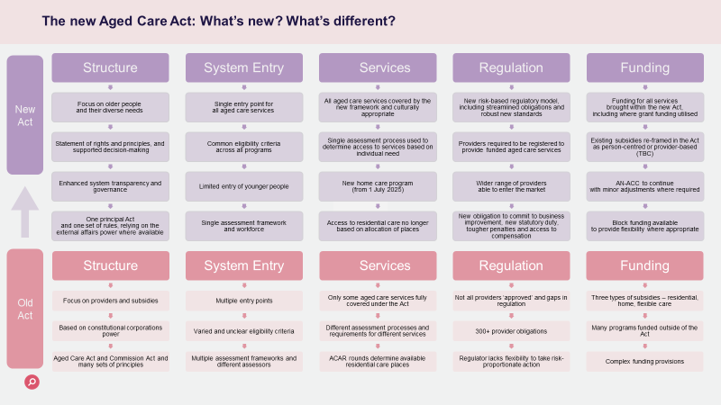

Additional resources
You can access additional resources by clicking here, including:
- Fact Sheet – A New Aged Care Act, and
- Frequently asked questions.
Consultation questions
We seek your feedback regarding the proposed structure, purpose and constitutional foundation of the new Act, with consideration to the following questions:
- Do you think the aged care legislative framework will be more accessible and transparent if there is a single piece of primary legislation and one set of Rules?
- Would you prefer to access separate topic-based subordinate legislation (like the current Quality of Care Principles 2014 and the Subsidy Principles 2014)?
- What else would you like to see included in the Objects of the new Act?
- Do you think it is a good idea to include a ‘Purpose Statement’ in the new Act, as well as objects provisions? What do you think the purpose of the new Act should be?
- Do you have any other feedback on the proposed structure of the new Act?
To provide your feedback you can:
- Complete the survey where you can tell us what is most important to you,
- Include a response to the consultation questions in a more detailed written submission to the Department.
- You can upload a submission or ask a question via the survey form.

The Statement of Rights
Recommendation 1 of the Royal Commission was that a completely new Aged Care Act be developed.
As well as broadly supporting a ‘rights-based’ approach to the new Act, the Royal Commission recommended that the new Act should include a Statement of Rights (Recommendation 2). Such a statement, together with pathways to have specified rights upheld, would help ensure that older people and their needs are placed, and remain, at the centre of the new aged care system.

A Statement of Rights as a centrepiece of the new Act
Subject to further consultation, the Department agrees that a Statement of Rights should be included in primary legislation and be a centrepiece of the new Act.
This will ensure that, unlike the current Charter of Rights (the Charter), the new Statement of Rights will have prominence and important symbolic, as well as practical, value.
It is intended that the Statement of Rights will clearly set out what people in the aged care system can expect when accessing, or seeking to access, funded aged care services.
It will empower users of the aged care system with the language to talk about their rights and provide clarity, and promote confidence among older people, their family members and representatives.
Placing the Statement at the forefront of the new Act will:
- ensure such rights have prominence and any future changes to those rights have significant parliamentary visibility,
- together with pathways for such rights to be upheld, support the proposed broader rights-based approach to the new aged care framework,
- provide clarity for, and promote confidence among, older people, their families and representatives about what they can expect from the aged care system,
- provide a reference point from which older people can advocate in complex or sensitive circumstances, and
- ensure that key overarching elements for the new system (Objects of the new Act, Statement of Rights and Statement of Principles) are all presented together in the front section of the new Act.

Which rights should be included?
It is proposed that the Statement of Rights outline the specific rights of people accessing, or seeking to access, funded aged care services under the new aged care system.
Subject to further consultation and consideration, it is intended that the Act recognise that such individuals have the right to:
- exercise choice and make decisions that affect their lives, be supported to make those decisions where necessary, and have those decisions respected, including where they:
  - involve personal risk, and
  - are made in pursuit of quality of life, social participation or intimate relationships,
- equitable access to have their need for aged care services assessed, including in a culturally appropriate manner,
- exercise choice between available aged care services they have been assessed as needing, and how these services are delivered,
- communicate in their preferred language or method of communication, with access to interpreters and communication aids as required,
- be treated with dignity and respect, including being listened to and informed, in a way they understand, about the services they are accessing,
- freedom from all forms of degrading or inhumane treatment, violence, exploitation, neglect and abuse,
- freedom from inappropriate use of restrictive practices,
- safe, fair, equitable and non-discriminatory treatment in accessing aged care services,
- equitable access to palliative and end-of-life care when required,
- be supported to exercise their rights, voice opinions and make complaints without fear of reprisal, and have complaints dealt with fairly and promptly,
- have their identity, culture and diversity valued and supported, including in accessing funded aged care services that are culturally appropriate, trauma aware and healing informed,
- their personal privacy and to have their personal information protected,
- seek, and be provided with, personal information about them held by Commonwealth agencies and registered providers, as well as information about their rights and the aged care services they access,
- have the role of persons who are significant to the individual acknowledged and respected,
- be supported by an advocate or a person of their choice, and
- opportunities and assistance to stay connected (if the individual chooses) with family members and other significant persons in the individual’s life, including safe visitation by family members and friends at reasonable times in residential care homes.
These proposed rights reflect, in part, wording proposed by the Royal Commission as derived from the International Covenant on Economic, Social and Cultural Rights, with additional content included to cover rights from the existing Charter, as well as feedback received from stakeholders.

How will rights be upheld under the new Act?
The Statement of Rights will be more than just symbolic, with pathways available to older people to have their rights upheld.
Subject to further consultation and consideration, it is intended that the new Act will specify that registered providers, responsible persons and aged care workers are expected to act consistently with the Statement of Rights, subject to law and any conflicting rights (for example, the rights of another person in the same room at a residential care home). It will also outline specific functions for the Department and the Commission, which will include promoting and upholding the rights of older people.
As outlined in the discussion paper: A new model for regulating aged care - Consultation paper 2 - Details of the proposed new model, it is proposed that registered providers will also be subject to a new obligation to have practices in place to ensure that they act consistently with the Statement. They will also be required to provide information to older people in their care about their rights.
The first step for any person who believes their rights, or someone else’s, have been breached will be to raise that breach with the registered provider and seek early resolution.
It is intended that it will be a condition on the registration of all registered providers to implement a complaints and feedback management system, which an older person (or their families or carers) can rely on when they consider their rights have been breached. These arrangements aim to ensure registered providers have responsive complaints processes in place, which will build greater trust and drive continuous quality improvements across the aged care sector. They are one of a number of elements, forming part of the proposed new regulatory model, that will help drive cultural change so that older people feel safe making complaints and registered providers respond to their concerns in a timely manner.
The intention is that an older person, who considers their rights have been breached by a registered provider or an aged care worker when seeking access to or accessing aged care services, will also be able to make or escalate a complaint to the Commission under a revised complaints process, led by the Complaints Commissioner. The Commission will then be able to pursue early intervention, conciliation or restorative outcomes (for example, an apology or an agreement to provide compensation).
In some, but not all circumstances, identified breaches of specified rights will also involve non-compliance with provider obligations under the new framework. A breach of a person’s rights may also amount to a breach of the Code of Conduct (Code) or the Quality Standards. For example, the Code places specific obligations on registered providers, responsible persons and aged care workers to provide funded aged care services free from all forms of violence, discrimination, exploitation, neglect and abuse; and sexual misconduct. Where a provider falls short of these obligations, formal compliance action and enhanced enforcement pathways will then be available to the Commission (see discussion paper: A new model for regulating aged care - Consultation paper 2 - Details of the proposed new model).
In addition, as discussed in more detail below, the specified rights will be given practical implementation through the operational provisions of the Act.

A rights-based approach
Adopting a rights-based approach to the new Act involves more than just including a Statement of Rights at the front of the new Act.
The diagram below outlines how rights are expected to be operationalised, including through:
- a rights-based legislative framework,
- an empowerment approach,
- clear rights and obligations on registered providers and aged care workers, and
- the new regulatory model.
For example, a right to equitable access to funded aged care services that takes into account the individual needs of older people will be practically implemented through:
- a single set of eligibility requirements to be included in the new Act (see discussion at Eligibility for funded Aged Care Services), and
- the assessment of a person’s individual needs through new Aged care assessment arrangements, which include a comprehensive assessment tool that will be used by a single assessment workforce and provide for specific First Nations assessment organisations and culturally-safe assessment processes.
The rights specified above will also form part of a broader empowerment approach for older people, which will be further supported in the new Act through:
- the implementation of new nominee arrangements which will be underpinned by a supported decision-making model to ensure increased protections for older people to maintain autonomy and dignity when accessing or seeking to access funded aged care services (see discussion at Supported decision-making),
- a revised approach to confidentiality and protected information to ensure that the new framework is more transparent, with more information available for older people to make informed decisions about their funded aged care services,
- a new complaints framework which will provide additional protections for whistleblowers and restorative pathways for older people accessing funded aged care services who have received substandard care (see discussion at Protections for whistleblowers), and
- support and funding for the advocacy network, which will help support older people to raise complaints about breaches of rights.
The following diagram shows how a rights-based approach will be reflected throughout the new Act, including through the structure and oversight of the new Act, providing for clear rights and obligations, empowering older people to make decisions and pathways for enforcement of rights.
You can access a full screen version of this diagram by clicking here.
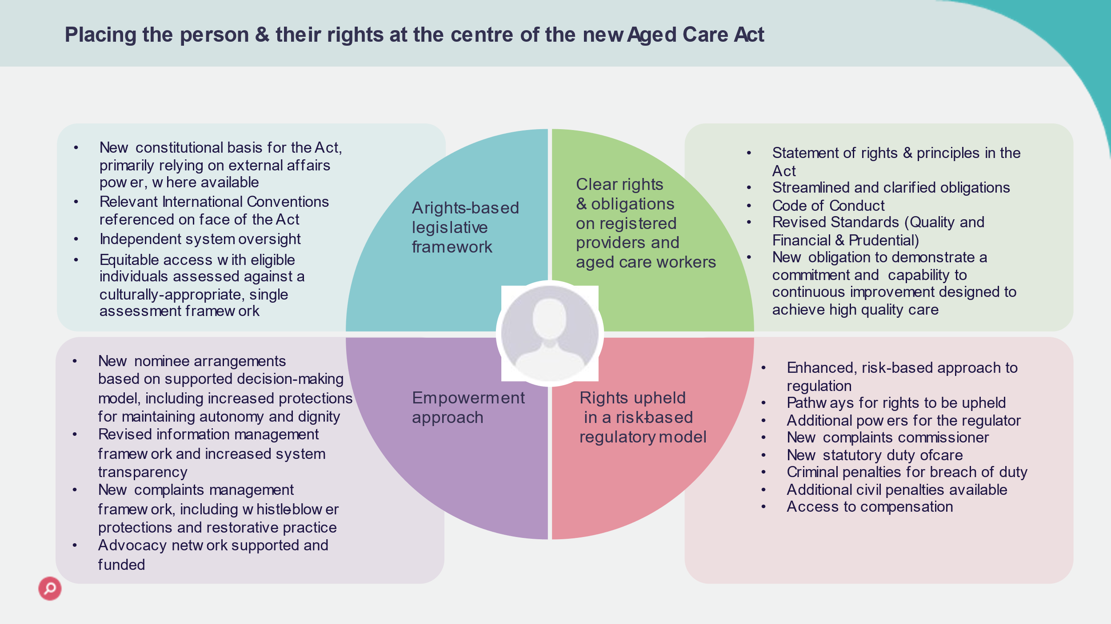

Additional resources
You can access additional resources by clicking here, including:
- Fact Sheet – New Aged Care Act: Statement of Rights, and
- Frequently Asked Questions.
Consultation questions
We seek your feedback regarding the Statement of Rights and enforcement pathways with consideration to the following questions:
- Do you support a Statement of Rights being included in the new Act?
- Are there any rights that you think we have missed that should be included?
- Are there any rights that you think should be worded differently?
- We consider it critical that person-centred complaints pathways are available for older people to seek early resolution of concerns about their rights. This is because the ideal scenario is where the registered provider or if necessary, the Commission can address risks early, instead of using enforcement mechanisms after harm has already occurred. Do you think we have the balance right?
To provide your feedback you can:
- Complete the survey where you can tell us what is most important to you,
- Include a response to the consultation questions in a more detailed written submission to the Department.
- Upload a submission or ask a question via the survey form.

Statement of principles
The Royal Commission recommended that the new Act should include a Statement of Principles (Recommendation 3).
We consider incorporating a Statement of Principles in the new Act will help guide decision making to ensure the new Act is administered in a manner consistent with its purpose.

The role of the Statement of Principles
The Royal Commission recommended that the new Act include both a Statement of Rights and a Statement of Principles. This is different to the National Disability Insurance Scheme Act 2013 (NDIS Act) which, only includes a list of guiding principles.
“The new Act should articulate the purpose and guiding principles of the new aged care system”
While some stakeholders have raised concerns about possible duplication between the two statements, we consider that both can play an important role in delivering cultural change within the aged care sector and ensuring the new Act achieves its intended purpose.
The Statement of Rights is expected to outline the specific rights of people accessing, or seeking to access, funded aged care services under the new aged care system. These rights, together with new clear and consistent obligations outlined in the legislative framework, will ensure registered providers and other workers within the aged care system have a common understanding of the outcomes expected when such services are delivered.
On the other hand, the Statement of Principles will guide the decisions, actions and behaviours of everyone operating in the aged care system (including, for example, the Department and the Commission).
Consistent with the Objects of the new Act, the Purpose Statement and operational provisions under the Act, the Statement of Principles will highlight the intended outcomes of the new legislative framework, including the new regulatory model. It will also provide an additional level of surety to the people accessing, or seeking to access, funded aged care services that their interests, needs and personal circumstances will be recognised and respected when actions are taken under the new Act.
Some rights and principles will directly complement each other. For example, an older person accessing aged care services will have a right to freedom from all forms of degrading or inhumane treatment, violence, exploitation, neglect and abuse. It will then be a principle for registered providers and aged care workers to deliver person-centred aged care services, free from any form of discrimination, abuse and neglect.

Which principles should be included?
It is proposed that the following principles be included in the Statement of Principles:
- The safety, health, wellbeing and quality of life of older people should be the primary consideration in the delivery of funded aged care services.
- The delivery of funded aged care services by registered providers and aged care workers should comprise the provision of person-centred care that:
  - takes into account dignity of risk, and the preferences, individual needs, goals and aspirations of older people
  - is free from any form of discrimination, abuse and neglect
  - treats older people as unique individuals, and with kindness, dignity and respect, and
  - in the case of First nations people, supports their personal connection to community and Country.
- The aged care system should put older people first, and support older people who access funded aged care services:
  - being able to reside at home if that is their choice, or, where that is not possible, in a setting appropriate to their circumstances, that is recognised as their home
  - being able to exercise individual responsibility and make decisions that enable them to lead active and fulfilling lives, including by engaging in the community and maintaining relationships with people where they choose to do so, and
  - being active and informed partners in decision-making as they wish about the funded aged care services delivered to them
  - maintaining or improving their physical and cognitive capabilities for as long as possible, with a focus on enablement, except where palliative care outcomes are discussed and agreed to by an older person or an appropriate representative, and
  - being aware of their rights when accessing funded aged care services.
- Where funded aged care services are required, the aged care system should offer accessible, culturally appropriate services for all older people, regardless of their location, including people of diverse backgrounds, people with alternative service needs and vulnerable people. This could include, but is not limited to:
  - First Nations people
  - peoples from cultural and linguistically diverse backgrounds
  - people who live in rural or remote areas
  - people who are financially or socially disadvantaged
  - veterans
  - care leavers
  - parents separated from their children by forced adoption or removal
  - people who are homeless or at risk of becoming homeless, and
  - people who identify as lesbian, gay, bisexual, transgender, intersex or queer.
- The aged care system should be transparent and provide public access to meaningful and readily understandable information about aged care.
- Government funding of aged care services should be used to support the delivery and regulation of services which provide targeted care and support for older people in need.
- The aged care system should not be used inappropriately to address service gaps in other care sectors or systems, preventing individuals from getting the best available care to meet their individual needs, goals and preferences.
- For younger people, alternative services that meet their needs are a preferred option to aged care services, which are designed to support the needs of older people.
- The aged care system should fund aged care services, which are not unlimited, for older people most in need - taking into account the individual needs of older people, and with individuals expected to meet some of the costs of services they use where they have the financial means to do so.
- The aged care system should incorporate effective networks to support:
  - continuity for older people accessing funded aged care services, and
  - access to integrated services that older people may require, with strong linkages with the health, mental health, disability and community services sectors.
- An effective aged care system should be supported by a diverse and sustainable market, as well as a trained and appropriately skilled workforce (including volunteers) – with aged care workers empowered to contribute to the delivery of high quality care and support ongoing business improvement across the aged care sector.
- Feedback and complaints about the delivery and accessibility of funded aged care services should be used to inform and promote continuous improvement in the aged care system.
- The regulation of the aged care sector should:
  - promote innovation, continuous improvement and contemporary evidence-based best practice within the aged care system,
  - identify failures and risks of failures within the aged care sector,
  - be responsive, risk proportionate, and principles based,
  - focussed on the health and safety of older people, and prioritised to areas of highest risk to older people,
  - promote the delivery of high quality, person-centred and culturally appropriate care to people accessing aged care services, and
  - strive for regulatory alignment with other care and support sectors where it is appropriate to do so and will benefit older people and the aged care sector.
- The Commission should undertake its functions, including its financial and prudential regulation functions, in a way that seeks to prompt and encourage registered aged care providers to operate viable services that ensure continuity of quality, safe care for people using them.
- The aged care system should be managed to ensure its sustainability and resilience, and that the Commonwealth’s investment represents value for money.
These proposed principles reflect, in part, wording proposed by the Royal Commission, with additional content included to cover feedback already received from stakeholders.

Additional resources
You can access additional resources by clicking here, including:
- Fact Sheet – New Aged Care Act: Statement of Principles, and
- Frequently Asked Questions.
Consultation questions
We seek your feedback regarding the Statement of Principles with consideration to the following questions:
- Do you support a Statement of Principles being included in the new Act as well as a Statement of Rights?
- Are there any principles that you think we have missed that should be included?
- Are there any principles that you think should be worded differently?
To provide your feedback you can:
- Complete the survey where you can tell us what is most important to you,
- Include a response to the consultation questions in a more detailed written submission to the Department.
- Upload a submission or ask a question via the survey form.

Definition of high quality care
As outlined in the public consultation paper A new model for regulating aged care - Consultation paper 2 - Details of the proposed new model and recommended by the Royal Commission (Recommendation 13), the new Act will include a clear definition of “high quality care” designed to lift the standard of funded aged care services provided to older people.

Why define high quality care?
Consistent with the Royal Commission’s vision for the aged care sector to aim higher and not just focus on minimum standards, the aim is for the new Act to deliver the foundations of an aged care system where:
- there is no place for substandard or low quality care,
- all registered providers deliver care as required under the new legislative framework, and
- high quality care becomes the norm as the system matures.
Including a definition of high quality care in the Act will ensure that this concept is central to the new Act and the new age care system – reflecting the desire to progress towards an aged care system that puts older people first.

High quality care definition
The intention is that the definition for high quality care will focus on the characteristics of care, as opposed to specific outcomes. This will enable the concept of high quality care to grow over time in response to community expectations. It will also differentiate the concept of high quality care from the ‘standard’ delivery of quality and safe aged care services in line with specific legislative requirements (e.g. Quality Standards).
Feedback on the proposed definition of high quality care was sought as part of consultation on the new regulatory model that will form a key part of the new Act. See: A new model for regulating aged care - Consultation paper 2 - Details of the proposed new model.

Subject to analysis of this feedback and further consideration, it is proposed that high quality care be defined as delivery of aged care services to a person who has been granted access to subsidised aged care services in a manner that prioritises:
- delivery of funded aged care services with compassion and respect for the individual, their life experiences, self-determination and dignity, and their quality of life,
- providing funded aged care services that are trauma aware and healing informed,
- providing funded aged care services that are responsive to the person’s expressed personal needs, aspirations, and their preferences regarding the manner in which services are delivered to them,
- facilitating regular clinical and non-clinical reviews to ensure that the services and supports delivered continue to reflect their individual needs,
- supporting the person to enhance their physical and cognitive capacities and mental health, and
- supporting the person to participate in cultural, recreational, and social activities, and remain connected and able to contribute to their community.

Achieving high quality care
A single measure or legislative reform will not achieve high quality care in the aged care sector. Instead, an integrated suite of measures, and ongoing effective governance and stewardship of the new aged care system is required.
The new regulatory model that will form a key feature of the new Act will be critical in this regard, with:
- a universal provider registration scheme,
- new streamlined obligations on registered providers - including a new obligation on certain providers to demonstrate the capability for, and commitment to, continuous improvement designed to achieve the provision of high-quality care,
- clear functions for the Commission and the Department to promote best practice and continuous improvement across the aged care sector,
- a Complaints Commissioner and revised complaints processes, and
- strong enforcement mechanisms to ensure action can be taken against registered providers who deliver substandard care.
See: A new model for regulating aged care - Consultation paper 2 - Details of the proposed new model.
New robust governance arrangements will also support the sector to continue to grow its capability to deliver high quality care.
The new system needs to be constructed and managed to ensure registered providers are funded, supported and incentivised to continually improve their services, and take into account, and balance the diverse needs of older people accessing aged care services and the challenges facing the sector, particularly in remote and regional Australia.
Quality must also continue to be measured through the National Quality Indicators Program and reported through the publication of Star Ratings.

Additional resources
You can access additional resources by clicking here, including:
- Fact Sheet – New Aged Care Act: Defining high quality care, and
- Frequently Asked Questions.
Consultation questions
We seek your feedback regarding the proposed definition of high quality care, with consideration to the following questions:
- Are there any changes you would make to the proposed definition of high quality care?
- Outside of the new regulatory model, are there any other initiatives that you would like to see addressed in the new Act to encourage registered providers to aim higher and deliver high quality care?
To provide your feedback you can:
- Complete the survey where you can tell us what is most important to you,
- Include a response to the consultation questions in a more detailed written submission to the Department.
- Upload a submission or ask a question via the survey form.

A new duty of care and compensation pathways
As outlined in the public consultation paper A new model for regulating aged care - Consultation paper 2 - Details of the proposed new model, the new Act will enable the Commission to access an expanded range of regulatory tools to take appropriate action against a registered provider, including additional enforcement mechanisms.
As part of the new regulatory model, it is also intended that the new Act include a new statutory duty of care on registered providers – with a pathway open, in certain circumstances, to seek compensation where an individual suffers illness or injury as a result of the breach of this duty. This would deliver the Government’s 2022 election commitment, and also address recommendations 14 and 101 of the Royal Commission.
More detailed discussion of these, and related initiatives, which are intended to complement the definition of high quality care, are provided below. They remain under consideration; however your early feedback is encouraged.

A new statutory duty on registered providers
As outlined in the public consultation paper A new model for regulating aged care - Consultation paper 2 - Details of the proposed new model, an overarching statutory duty of care on registered care providers is being considered for inclusion in the new Act.
The new duty would be modelled on the work, health and safety duty outlined in section 19(1) of the Work Health and Safety Act 2011 (WHS Act), as recommended by the Royal Commission – with registered providers required to comply with the duty so far as is reasonably practicable, taking into account matters such as, for example, dignity of risk and rights of the individual accessing funded aged care services.
The duty will not, however, be a duty of high quality care as recommended by the Royal Commission. This is because criminal penalties, as committed to by the Government, are unable to be attached to a duty to deliver high quality care, which cannot be defined with sufficient legal clarity.
To introduce such a duty would also mean that high quality care would become a minimum standard. We want the concept of high quality care to grow over time and be able to be differentiated from the standard delivery of quality and safe funded aged care services in line with legislative requirements. We also want to encourage, not limit, innovation and continuous improvement by registered providers.
Instead, the new duty will be focussed on ensuring registered providers take reasonable steps to avoid their actions adversely affecting the health and safety of persons in their care.
Not all actions of a registered provider that adversely affect the health and safety of persons accessing funded aged care services would, however, amount to a breach of the duty.
It is intended that the new Act will provide that only serious failures to act in a manner consistent with the duty will amount to a breach of that duty. As outlined below, penalties will also only apply where a failure to take reasonable steps results in a risk to, or actual serious illness, injury or death of an individual to whom the duty is owed.
The duty will form part of the new regulatory model, providing the Commission with another option to take action against registered providers in serious cases, and importantly, opening a compensation pathway in certain circumstances as discussed in more detail below.
The intention is that the new duty would complement, not displace, existing WHS and common law duties, as well as any existing duties under State and Territory legislation.

Duties on other individuals and entities

Responsible persons of registered providers
Subject to further consultation and consideration, it is proposed that the new Act also include a separate duty on responsible persons (and/or governing persons) to exercise due diligence, that is takes reasonable steps, to ensure that the registered provider complies with the statutory duty discussed above.
This is similar to the duties on officers under section 27 of the WHS Act.
This would recognise such people have responsibilities, as well as the potential to strongly influence the culture and accountability of a registered provider, through their decisions and behaviours. They can also influence important decisions on the resources made available to provide quality and safe care, and policies developed to support compliance by the registered provider with the proposed new statutory duty.
While this approach does not go so far as introducing accessorial liability as recommended by the Royal Commission, we consider it will increase accountability for serious failings in the provision of funded aged care services and expand the regulatory tools available to the Commission when dealing with serious breaches of the duty.
As outlined below, it is proposed that penalties for breach of the duty by a responsible person will only attach to very serious behaviour of concern, so responsible persons would not face criminal penalties due to actions that do not significantly put an older person accessing funded aged care services at risk. What steps are considered reasonable to take will also depend on the circumstances, including the role and influence of the individual.

Aged care workers
The Department is also considering imposing a statutory duty on aged care workers to:
- take reasonable care that their acts or omissions do not adversely affect the health and safety of individuals to whom they provide care
- comply, so far as they are reasonably able, with any reasonable instructions that is given by the registered provider to allow the person to comply with the Act, and
- cooperate with any reasonable policies put in place by the registered provider in relation to ensuring the health and safety of persons to whom they are providing funded aged care services.
This is similar to the duties on workers under section 28 of the WHS Act.
We note that this departs from the Royal Commission’s findings, however, there is also risk posed to individuals by aged care workers, not just registered providers and their responsible persons. This is because they are directly responsible for the care of older people and have responsibilities to follow directions to ensure they remain safe.
As outlined below, penalties for breach of the duty by an aged care worker would also target very serious behaviour of concern, so individual workers would not face criminal penalties due to actions that do not significantly put an older person accessing funded aged care services at risk.

Organisations that facilitate access to aged care services
In response to Recommendation 14 of the Royal Commission, the Department is also considering whether a separate type of duty should be imposed on organisations that facilitate access to funded aged care services (for example, digital platforms that advertise the services of aged care workers and help link up older people with providers of aged care services).

Penalties
Subject to further consideration and consultation, it is intended that tiered offence provisions will be outlined in the new Act for breaches of the duties outlined above. Consistent with the Government’s 2022 election commitment, these provisions will provide for criminal penalties to attach to a breach of a duty that results in the risk of, or actual, serious illness, injury or death to an individual to whom a duty is owed.
Applicable penalty units remain under consideration; however, the intention is that higher penalties would be available where the person is reckless as to the risk of death or serious injury or illness to an older person.
The intention of this approach is to target the behaviour of substandard registered providers, responsible persons, governing persons and aged care workers who consistently do the wrong thing with no, or little regard, for the safety and well-being of older people.
The Commission would then be able to deal with other more minor behaviour of concern, which amounts to a breach of other requirements under the new legislative framework, via other regulatory tools on a risk proportionate based, as outlined in A new model for regulating aged care - Consultation paper 2 - Details of the proposed new model.
To further address Recommendation 101 of the Royal Commission, it is also intended that higher level civil penalties will be available to the Commission where a registered provider repeatedly fails to comply with conditions on their registration, including by failing to demonstrate the capability for, and commitment to, continuous improvement aimed at achieving high quality care. This will complement the proposed penalty provisions related to breaches of a duty of care.

New compensation pathway
As outlined in the public consultation paper A new model for regulating aged care - Consultation paper 2 - Details of the proposed new model, it is intended that a compensation pathway be available in certain circumstances where a registered provider breaches their statutory duty.
This new pathway would complement, not replace, existing compensation arrangements for personal injury. It is not meant to alter the way in which people seek compensation, or otherwise affect any existing rights to compensation under common law or applicable State and Territory legislation.
Subject to further consultation and consideration, the new compensation pathway would be limited to breaches by a registered provider of the criminal offence provisions discussed above, where the actions of the provider result in serious illness or injury to an older person accessing funded aged care services.
It would not be available where a court has determined that a registered provider has breached a civil penalty under the new Act, as recommended by the Royal Commission (Recommendation 102). We consider that extending the compensation pathway to all civil penalty breaches by registered providers would be problematic. It could hamper the Commission’s efforts to take a risk proportionate approach to regulating the sector.
We want to ensure the Commission can focus its resources on a relational approach to regulation, as well as restorative outcomes for older persons accessing funded aged care services. The aim is to ensure that older people are not subjected to substandard care in the first place, and that their concerns can be addressed through early intervention wherever possible, without the need to resort to litigation.
As recommended by the Royal Commission, the new Act may provide for the Commission to seek a court order for compensation in the circumstances outlined above. In addition, consistent with Recommendation 102, it is expected that individuals who have suffered serious illness or injury could seek a court order themselves.
It is relevant to note that other pathways for an individual to be compensated may also be available under the new aged care system. As outlined in the public consultation paper A new model for regulating aged care - Consultation paper 2 - Details of the proposed new model:
- compensation may be available where agreed to between the complainant and a registered provider, with the Commission to adopt a restorative approach to complaints resolution, and
- the Commission may accept and enforce an undertaking from a registered provider to comply with certain provisions under the new Act, which could include an undertaking to provide compensation to a person accessing funded aged care services who has been impacted by their non-compliance.

Additional resources
You can access additional resources by clicking here, including:
- Fact Sheet – New Aged Care Act: A new duty of care and compensation pathway,
- Fact Sheet – New Aged Care Act: Holding registered providers accountable, and
- Frequently Asked Questions.
Consultation questions
We seek your feedback regarding the proposed approach to penalties and compensation pathway, with consideration to the following questions:
- Do you support inclusion of the new statutory duty of care in the new Act?
- Do you think the new duty could result in any unintended consequences?
- Do you support related duties being placed on responsible and governing persons of aged care providers?
- Do you think a related duty should be placed on aged care workers?
- Do you think a separate duty should be placed on organisations that provide enabling services and/or facilitate access to aged care workers? What should be the extent of such a duty?
- Do you have any further feedback on the proposed approach to compensation?
To provide your feedback you can:
- Complete the survey where you can tell us what is most important to you,
- Include a response to the consultation questions in a more detailed written submission to the Department.
- Upload a submission or ask a question via the survey form.

Disclosure protections for whistleblowers
The Royal Commission said in Chapter 14.4.8 of their Final Report that fear of reprisal may deter older people and aged care workers from making complaints about a provider. The Royal Commission compared the whistleblower protections for aged care with those in the Corporations Act 2001 (Corporations Act) and recommended that the current aged care protections should be expanded to align more closely with the Corporations Act.

Current Arrangements
Under the current Aged Care Act, whistleblower protections are limited to disclosure of information about reportable incidents under the Serious Incident Response Scheme (SIRS). Recent amendments to the Aged Care Act extended the scope of SIRS to include aged care services delivered in home and community settings, however compared to other Commonwealth whistleblower schemes, this is a narrow approach.

Proposed changes
It is the intention to broaden whistleblower protections to be similar to protections in the NDIS Act and under the Corporations Act.
Under the proposed scheme, a disclosure can be made by a broad range of people, including:
- aged care workers (whether directly employed or contracted, and paid or unpaid)
- responsible and/or governing persons of registered aged care providers, and
- older persons accessing funded aged care services, and those close to those persons such as carers, family members and advocates.
Those people will be able to make a disclosure about contraventions, by certain persons, of the aged care legislation to officials, including:
- staff of the Commission or the Department,
- aged care workers (whether directly employed or contracted, and paid or unpaid),
- governing or responsible persons of registered providers,
- police officers, and
- anyone else authorised to receive that information.
When making a disclosure, a person will have to provide their name to the official in order to be protected as a whistleblower. However, this will not prevent complaints being made anonymously through other avenues.
The whistleblower will need to have reasonable grounds to suspect that a registered provider, aged care worker, (whether directly employed or contracted, or paid or unpaid), a responsible or governing person of a registered provider has, or even may have, contravened any provision of the aged care legislation. and the disclosure will also need to be made by the person in good faith.
The proposed approach is intended to ensure that people feel empowered to disclose information where they think certain persons might have breached the aged care legislation, without fear of repercussions.
This is essential for protecting older people accessing funded aged care services and is intended to enable the identification of events before they become reportable incidents.
The following diagram sets out who can make disclosures, who disclosures can be made to and other requirements for making a disclosure.
You can access a full screen version of this diagram by clicking here.
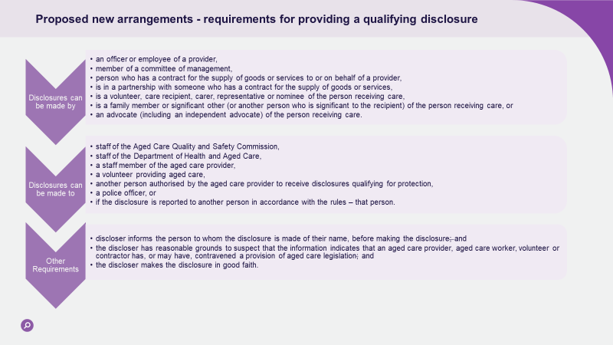

What protections will be made available?
Where a person makes a qualifying disclosure, they will be protected from consequences, including civil, criminal and administrative liability, as well as contractual or other remedies.
The current protections against victimisation will be retained in the new Act. This means that any person (including people other than the whistleblower themselves) who is victimised due to the whistleblower disclosure will be protected. This covers, for example, where an older person’s family member makes a disclosure on their behalf, and it is the older person who is suffers consequences.
This means that it would be a civil offence to engage in conduct that causes detriment, or even threatens to cause detriment, to a person, because of a disclosure they, or another person has made.
This protects people from any retribution from people who have contravened aged care law.

Confidentiality of Whistleblowers
Like the Corporations Act, it would be an offence to disclose a whistleblower’s identity (or information that might lead to their identification) where they have made a qualifying disclosure.
However, to allow for information to be dealt with and investigated appropriately, it will be necessary to include some limited exceptions to disclosing the whistleblower’s identity. Proposed exceptions include disclosure to:
- the Commission, the Department, or any other body with a legislated function concerning the investigation of information provided by the whistleblower to the extent necessary for them to perform their function (for example the Australian Federal Police),
- the responsible person of a registered provider,
- a legal practitioner for the purposes of obtaining legal advice,
- where the disclosure is necessary to lessen or prevent a serious threat to the safety, health or well-being of a person accessing funded aged care services, or
- with express or implied consent of the whistleblower.
It is intended that the Rules will allow some limited scope for further exceptions to be prescribed if that becomes necessary in the future.

Obligations of Aged Care Providers
It is proposed that the new Act will include an obligation for registered aged care providers to have an internal whistleblower policy which provides guidance for both potential whistleblowers, and people authorised to receive disclosures. It is intended that this obligation may include requirements around:
- publicising the way in which a person can make a disclosure and how to do so in a way that meets the whistleblower protection requirements (discussed above),
- training and education requirements for staff of registered providers who may receive disclosures, and
- appropriate processes for handling disclosed information, including escalation to the Department or the Commission as appropriate.
The intention of whistleblower protections is to make people feel confident to raise issues that may put older people at risk and leads to effective change.

Additional resources
You can access additional resources by clicking here, including:
- Fact Sheet – New Aged Care Act: Protections for whistleblowers, and
- Frequently Asked Questions.
Consultation questions
We seek your feedback regarding the proposed approach to disclosure protections for whistleblowers, with consideration to the following questions:
- What challenges could there be with the proposed whistleblower framework, and do you have any proposed solutions?
- What other barriers are there to people disclosing information about what they observe in the aged care system, and how can these best be overcome?
To provide your feedback you can:
- Complete the survey where you can tell us what is most important to you,
- Include a response to the consultation questions in a more detailed written submission to the Department.
- Upload a submission or ask a question via the survey form.

Supported decision-making arrangements
In making its recommendation that the Aged Care Act be replaced with a new Act, the Royal Commission recommended that the new Act specify the rights of older people, including the right of autonomy, the right to the presumption of legal capacity, and in particular the right to make decisions about their care, the quality of their lives and the right to social participation (Recommendation 2(b)(ii)).
The Final Report also recommended that aspects of the new system introduced through the new Act should maintain the cognitive capabilities of older people and support their autonomy and self-determination (Recommendation 3(b)(iii), (v), and (xi) and Recommendation 28(1)(d)).
The new Act is an opportunity to ensure that the role of legal representatives and their responsibilities relating to supported decision-making is clarified. The proposed representative arrangements are intended to provide clarity and consistency across aged care law and systems. The approach has been developed by considering nominee arrangements under other existing statutory schemes and best practice models recommended by inquiries.

Existing arrangements for aged care
Under current aged care legislation there are inconsistent references to ‘legal representatives’, ‘representatives’, and ‘nominated representatives’. The existing legal arrangements do not explain the process for appointment, or make it clear where a representative should be involved rather than to the care recipient themselves. Without a clear process for appointment this is left to the approved provider to manage, and it is at their discretion to determine a person’s capacity and a representative’s involvement, which has led to conflicts of interest.
My Aged Care has established administrative (non-legislative) arrangements that allow for the appointment of a ‘representative’ on a consumer’s behalf. ‘Regular’ and ‘authorised’ are two types of My Aged Care representatives that may be appointed. The differences between these types of representatives are summarised in the following table:
My Aged Care representative arrangements
Regular representative | Authorised representative | Agent
- Voluntarily appointed by consumer  - Can directly communicate with My Aged Care, assessor and provider  - Receives duplicate written correspondence (unless consumer opts out)  - Should seek permission/consult consumer on all decisions and actions taken on their behalf | - Only if consumer unable to provide consent  - Person applies to  My Aged Care to become consumer’s authorised representative  - Must attach specified legal documentation to application (e.g. guardianship order)  - Able to act and make decisions on consumer’s behalf and receive all written correspondence  - If consumer communicates with  My Aged Care, authorised representative must be present | - Approved body or entity such as an advocacy organisation  - Voluntarily appointed by consumer  - Can directly communicate with  My Aged Care  - Receives duplicate correspondence  - Supports the person to make their own decisions but cannot make decisions or take actions on their behalf

Interaction with other Commonwealth Laws
Similar to the interaction with State and Territory Laws, the nominee arrangements under the new Aged Care Act will not replace any other nominee frameworks that exist under other Commonwealth laws, including the National Disability Insurance Scheme and social security law (i.e. Services Australia). While nominees appointed under the new Act will be authorised to act under the new Aged Care Act only, it is intended that there should be consistency, where appropriate, across the various schemes.

Interaction with State and Territory Laws
Consistent with nominee arrangements under the National Disability Insurance Scheme, it is proposed that the new Aged Care Act would operate in parallel to state and territory laws. The new Act would authorise representatives to act on an aged care recipient’s behalf, in last resort situations, for the purposes of decisions and actions under the new Aged Care Act only.
As a representative’s powers will be limited to the decisions or actions for the purposes of the new Aged Care Act, they will not be required to already have authority to act on a person’s behalf through other laws. It is proposed that when the Secretary or their delegate is appointing a representative for a person, they will be required to have regard to whether a person is authorised to make decisions for the aged care recipient under other laws. While it is anticipated that in most circumstances authority under other laws would provide support for the appointment of that person as a representative, it does not necessarily bind the Secretary to appoint that person if there are reasonable grounds not to (for example, if the person receiving aged care wants someone else to be their representative for aged care or concerns have been raised about elder abuse).

Criteria for appointment
Consistent with other established models it is proposed that there would be two types of representatives under the new Act. Drawing inspiration from two similar roles recommended by the Australian Law Reform Commission (ALRC) it is proposed that there will be ‘supporter’ and ‘representative’ nominees. While an older person may be able to have either a supporter or representative nominee, they will not be able to have both types of nominees at one time.
Based on the existing nominee model under the National Disability Insurance Scheme (NDIS), it is proposed that the Secretary (or delegate) may appoint a nominee at the request of an older person who is accessing, or seeking to access, funded aged care services or appoint a representative nominee for such a person on their own initiative. When making an appointment it is proposed that the Secretary must:
- take into consideration the wishes of the older person (if any),
- ensure the proposed nominee has provided consent to fulfil the role of a nominee,
- be satisfied that the proposed nominee would be able to fulfil the duties of a nominee, and
- have regard to whether there is a person who has the authority to make decisions on behalf of the older person under the law of the Commonwealth, a State or a Territory, or under an appointment by a court, tribunal, board or panel (however described).

This will ensure that appointments under these existing arrangements are taken into consideration, but does not bind the Secretary (the System Governor) to appoint that person as the older person’s nominee. The nominee will be authorised to act or make decisions on the older person’s behalf for the purposes of the new Act. This means that authorisation through other mechanisms discussed above is not required for the purposes of being appointed as a nominee under the new Act. While it is likely that authorisation through other means will support the appointment of a person as the older person’s nominee, it will also ensure the System Governor has discretion to appoint a different person as a nominee if it is considered appropriate in the circumstances.
It is also proposed that the System Governor will have the power to appoint a nominee for a specified term and to also cancel or suspend an appointment in certain circumstances consistent with existing arrangements under the NDIS.
In practice it is proposed that it will be the role of the System Governor to notify the older person and their registered provider/s of the appointed nominee including their contact details, and notify these parties of any changes to that arrangement.

Role of a supporter
It is proposed that in general, a supporter would be able to support an older person to navigate the aged care system, but they would not have the authority to make any decisions in relation to the new Act on the older person’s behalf. The supporter will be able to receive duplicate correspondence as consented to by the older person and be able to assist them to communicate their own decisions where that is appropriate. Having this person identified through an appointment as a supporter will ensure that registered providers and the System Governor are aware that there is someone who is trusted by the older person who is aware of their circumstances and can be called in to assist the older person if required.

Role of a representative
It is proposed that a representative can do any act that may be done by the older person for the purposes of the new Act, including making decisions on behalf of the older person.

Supported decision-making principles and duties
The new Act will set out duties for both supporters and representatives. For example, nominees will be required to:
- ascertain the views, wishes and preferences of the person accessing, or seeking to access funded aged care services when supporting/representing them, and
- act in a manner that promotes the person’s personal and social wellbeing and strives to maintain their capacity to make their own decisions.
These duties reinforce the principle that people should be presumed to have the capacity to make decisions for themselves or be assisted in making decisions for themselves. This aims to promote the maximum autonomy and control of older people over their lives and the aged care they receive.
The key change is that the new Act will include a specific duty for a representative to refrain from doing an act, or making a decision, on a person’s behalf unless:
- they are satisfied that it is not possible for the person to do, or to be supported to do, that act or make that decision themselves, or
- it is possible for the person to do the act or make the decision, but they want the representative to make that decision on their behalf.
Consistent with the recommendations of the ALRC, a representative must also comply with the following decision-making principles when they are required to make a decision or undertake an action on a person’s behalf:
Decision-making principles:
- if known, the representative must ensure the person’s views, wishes and preferences are given effect
- where the person’s current will and preferences cannot be determined, the representative must give effect to what the person would likely want, based on all the information available, including by consulting the person’s partner or other close family and friends (to the extent possible)
- If it is not possible to determine what the person would likely want, the representative must act to promote and uphold the person’s human rights and act in a way least restrictive of those rights Note: a representative nominee may override the person’s will and preferences only where necessary to prevent harm.

The following diagram shows the steps for making a proposed nominee arrangement under the new Aged Care Act.
You can access a full screen version of this diagram by clicking here.
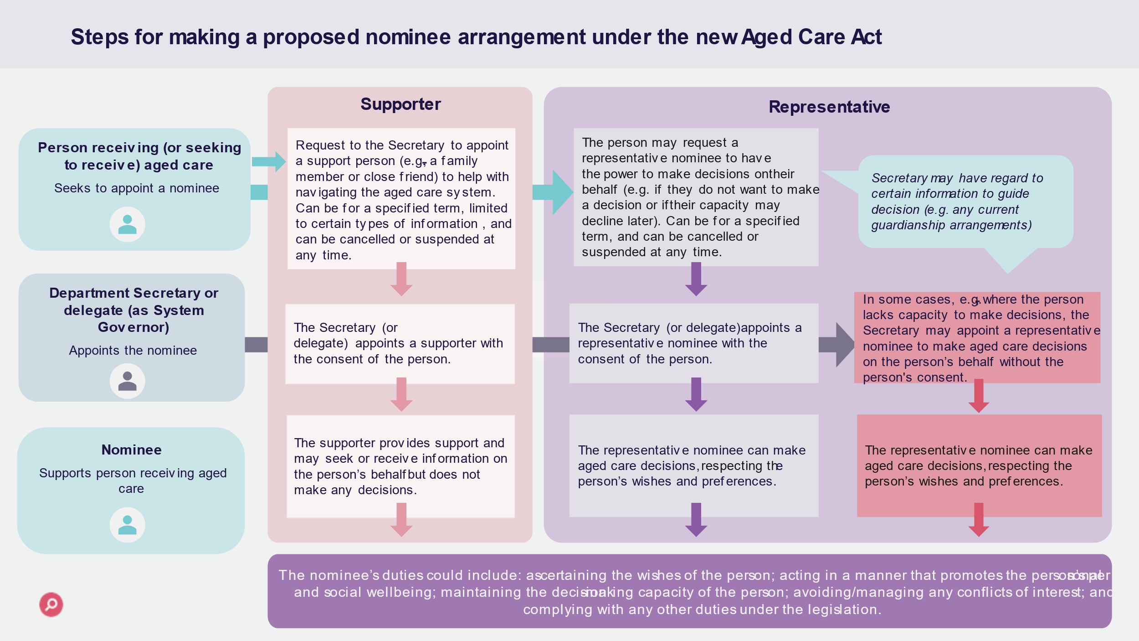

Additional resources
You can access additional resources by clicking here, including:
- Fact Sheet –New Aged Care Act: Nominee arrangements and supported decision-making, and
- Frequently Asked Questions.
Consultation questions
We seek your feedback regarding the proposed approach to embedding supported decision making, with consideration to the following questions:
- What are your views on the proposed nominee framework?
- What challenges could there be with the proposed framework, and do you have any proposed solutions?
- Are there any other duties or obligations you think should be put on appointed nominees?
- When do you consider a supporter nominee would be most useful to a recipient of aged care services? For example, to convey decisions, understanding processes, receiving and explaining correspondence in a way which is understood by the older person.
- What kind of information do you think support nominees should receive?
- Are there any categories of information that support nominees should not receive?
- How can the Department best support the transition from current My Aged Care arrangements to the new nominee arrangements? Are there any implementation issues you are concerned about?
To provide your feedback you can:
- Complete the survey where you can tell us what is most important to you,
- Include a response to the consultation questions in a more detailed written submission to the Department.
- Upload a submission or ask a question via the survey form.

Eligibility for funded Aged Care Services
The new Act will establish a new entry point into the aged care system, with common eligibility requirements and a single assessment framework for all funded aged care services.
This is consistent with the person-centred approach to the new Act, but also addresses the Royal Commission’s recommendation (Recommendation 25) that the new aged care program should have some core features, including a common set of eligibility criteria and a single assessment process based on a common assessment framework.
Proposed new eligibility requirements are discussed below. For more information on proposed new assessment processes, including the single assessment framework, see the Department’s website on Aged care assessment arrangements.

Overview of current eligibility requirements
Under the current Act, a person’s eligibility is tied to the type of aged care a person is eligible to receive, which is in turn tied to the setting in which care will be provided. Broadly speaking, the eligibility criteria are:
- that the person has physical, medical, social or psychological needs that require the provision of care; and
- those needs can be met appropriately through residential/home/flexible care services (as appropriate).
There are currently no citizenship or residency requirements to access the aged care system. Age requirements also remain unclear and are not consistent. The current Act does not exclude younger people from being eligible for aged care. However, under the Care Recipients Principles, a person who is not an aged person is only eligible to receive residential care, if they are assessed as having a condition of frailty or disability requiring continuing personal care and incapable of living in the community without support, and there are no other care facilities or care services more appropriate to meet the person’s needs.
Age requirements only apply, outside of the current Act, to the Commonwealth Home Support Program (CHSP) – that is, 65 years of age; or 50 years or older for First Nations people or those who are homelessness or at risk of homelessness (or 45 for those who fall into both categories).

Issues with current arrangements

Complex and inconsistent eligibility requirements
As was highlighted by the Royal Commission, the current framework does not provide for a simple logical sequence for an older person to enter aged care. There are multiple programs and services, each with specific eligibility requirements and assessment processes. For example, eligibility requirements are inconsistent across current in-home aged care programs, including those that are addressed in the current Act and those that sit outside the Aged Care Act, and they can depend on where services are being delivered.
The Royal Commission raised concerns that the process of obtaining aged care is ‘complex and prone to inefficiency and duplication’ – describing it as time-consuming and overwhelming, and even frightening and intimidating. It considered that: ‘There should be one aged care program, with one set of eligibility criteria, one assessment process and one entitlement to the supports and care that meet people’s needs.’

Younger people in residential aged care (YPIRAC)
The Final Report raised specific concerns about the situation of younger people in residential aged care, who may experience isolation, desperation and loneliness if they are unable to access more suitable accommodation and supports.
The Royal Commission stated that:
“No younger person should have to live in residential aged care. Aged care is not intended for younger people and does not meet their needs.”
It was also raised at the Royal Commission hearings by Counsel that continuing to house young people within residential aged care facilities could also offend fundamental human rights principles as set out in Article 19 of the Convention on the Rights of Persons with Disabilities, which is concerned with the right to live independently in the community.
The Royal Commissioned recommended (Recommendation 74) that, with very limited exceptions, no person under the age of 65 years should live in residential aged care from 1 January 2025 – a target which has been committed to by Government.

A simpler and fairer approach for accessing aged care
The intention is that the new Act will provide for a common entry point for access to the new aged care framework – with all individuals seeking access to aged care services required to go through the same process and meet certain threshold eligibility requirements, irrespective of what type of aged care services they believe they may require access to.
The aim is to achieve a simple ‘gateway to Aged Care’ in the new Act and limit the need for older people to tell their story on repeat occasions – reflecting the person-centred approach of the new legislation.
Key benefits for older people include:
- a single application process for all funded aged care services
- one common set of eligibility requirements for all aged care programs
- no need for eligibility to be re-assessed for different programs
- transparent requirements – with a delegate to decide whether they are eligible for a needs assessment, and this decision a reviewable decision, and
- streamlined evidentiary requirements for aged care needs proposed to be adopted for certain referral pathways (for example, referral from a medical perspective).

Proposed access and eligibility arrangements under the new Aged Care Act
All individuals seeking access to funded aged care services under the new Act will be required to:
- make an application for funded aged care services
- have their eligibility for an aged care needs assessment determined (see Threshold eligibility test below)
- undergo an individual needs assessment, which will inform a decision as to whether they can access funded aged care services and, if so, which ones and when.

The diagram below presents this process at a high level.
You can access a full screen version of this diagram by clicking here.
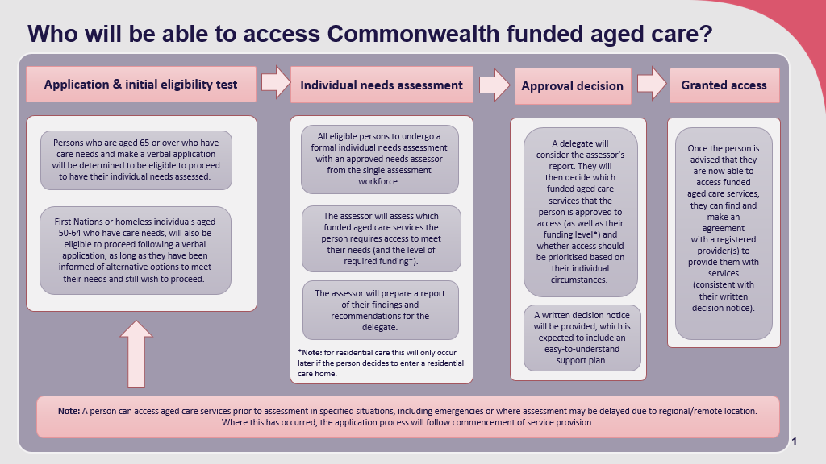
An application will be able to be made verbally, with no application fees required. This can be done by the person seeking access to funded aged care services or, for example, their supporter or representative.
At this point additional information might be requested in order to determine that requirements are met.

Threshold eligibility test
When a person applies for funded aged care services, they will proceed to assessment if they are determined to meet certain threshold criteria.

Individuals aged 65 and over
Individuals aged 65 and over, who have care needs, will be considered eligible to proceed to a formal needs assessment.
Care needs is to be defined in the new Act. It is proposed that a person be considered to have care needs if they:
- have difficulty (whether physical, mental or social) undertaking any daily living activities (for example, getting out of bed or chairs; walking; going to the toilet, wipe and re-dress; taking a bath or shower; getting dressed; eating or preparing a meal; taking medicine; basic housework, basic home or garden maintenance; driving or taking public transport; shopping for groceries; managing money and paying bills), and/or
- require the assistance of an aid(s), or help from another person, to maintain their physical, psychological, or social capacity to function independently.
This requirement is designed to ensure that individuals who do not have any care needs at all do not proceed to a formal needs assessment. This will reduce the time and cost associated with formal assessment processes where a person does not need aged care services.
In practice, it is intended that care needs would be established by a person’s own declaration or a referral (for example, from a medical professional).

Individuals under the age of 65
Consistent with the findings of the Royal Commission (Recommendation 74) and agreed targets related to residential aged care and younger people, it is intended that access to the aged care system for individuals aged under 65 be clear, limited and strictly controlled.
As a result, it is intended that only specific cohorts of people under 65 who have care needs as a result of their life experiences, would be able to access the aged care system.
That is, where the person is 50 – 64 years of aged and is either:
- a First Nations person, or
- is homeless or at risk of homelessness.
In addition, to be eligible for a needs assessment, such younger individuals will need to have:
- been informed of alternative options available to meet their needs, and,
- expressed that access to aged care service is their will and preference taking into account the information provided regarding alternative options.
The Act will not require additional documentary evidence of alternative options to be provided to establish this.
This approach is considered important to ensure that the new aged care system does not create further impediments or perceived barriers to accessing aged care for First Nations peoples – with the Royal Commission highlighting concerns that First Nations people do not access aged care at a rate commensurate with their level of need.
However, it also takes into account the Royal Commission’s findings that care still needs to be taken to ensure that First Nations people who are aged over 50 years but under 65 years, with conditions that affect their ability to function, do not move straight into the aged care system where they may miss out on the full range of NDIS assistance that they would otherwise be entitled to.
No other younger persons will be able to access funded aged care services. This will ensure that:
- Government funding of aged care services is used to support the delivery and regulation of services which provide targeted care and support for older people in need, and
- the aged care system is not used inappropriately to address service gaps in other care sectors or systems, preventing individuals from getting the best available care to meet their individual needs, goals and preferences.
The Department will be working with other Commonwealth agencies, and State and Territory Governments, in the lead up to the commencement of the new Act to ensure, that younger people are able to access alternative services that meet their needs instead of being left with no option but to access aged care services, which are designed to support the needs of older people.

Additional resources
You can access additional resources by clicking here, including:
- Fact Sheet –New Aged Care Act: Eligibility for aged care services, and
- Frequently Asked Questions.
Consultation questions
We seek your feedback regarding the proposed approach to embedding supported decision making, with consideration to the following questions:
- Do you support the proposed eligibility requirements under the new Act?
- Do you have any concerns about people under 65, unless homeless or First Nations and over 50, being excluded from entering funded aged care services?
- Are there other things you would like to see changed about entry arrangements for the aged care system?
To provide your feedback you can:
- Complete the survey where you can tell us what is most important to you,
- Include a response to the consultation questions in a more detailed written submission to the Department.
- You can upload a submission or ask a question via the survey form

Appendix A

Glossary of terms
Term | Definition
Aged Care Quality and Safety Commission | In the current regulatory model, the aged care Regulator is the Aged Care Quality and Safety Commission. The Department will administer other parts of the legislation as the System Governor.
Code of Conduct for Aged Care | The Code of Conduct for Aged Care sets out what older people and the community can expect from aged care providers, governing persons, and workers. It aims to improve the safety, health, wellbeing, and quality of life of aged care recipients by promoting ethical, honest, and respectful behavior, building trust in aged care services, and protecting older people against workers who pose an unacceptable risk of harm. The Code of Conduct for Aged Care was implemented on 1 December 2022.
Compliance | Compliance is the process of making sure aged care providers and workers meet their responsibilities in delivering care and services.
Condition of Registration | Conditions are a subset of provider obligations that are applied to registration. A registered provider will be required to comply with any conditions placed on their registration. These conditions will outline specific obligations that the provider must meet. Some conditions will apply to all providers, some to providers in certain categories only and some to specific providers only. What a provider needs to do to meet a condition may also vary across registration categories.
Department | The Department of Health and Aged Care which is the System Governor and has responsibility for the operations and oversight of Commonwealth funded aged care.
Enforcement | Enforcement refers to actions taken by the Aged Care Quality and Safety Commission (the Commission) to address aged care providers or workers who are not meeting applicable laws or responsibilities.
Funded aged care services | This refers to aged care services for which Commonwealth funding is available. Registered providers will be able to claim a subsidy for delivery of these services. Alternatively, or in addition, grant funding may also be available to registered providers.
Incident management | Incident management sets the responsibilities of aged care providers and workers to prevent, fix and reduce issues of abuse and neglect. It also includes when they need to tell the Commission about serious incidents that have happened.
My Aged Care | My Aged Care is the entry point to the Australian aged care system. It provides general information about aged care services, and can register, screen, and refer eligible older people for an aged care assessment.
Obligations | Obligations refer to ‘what’ a registered provider must do to comply with the aged care legislative framework – and hence, the actions or behavior that will be required of them. A failure to comply with one or more obligations that apply to them under the legislative framework could result in enforcement action being taken against the provider – for example, penalties, fines or other legal action. Obligations include conditions of registration.
Quality Standards | The Quality Standards focus on the essential systems and controls providers must have in place to achieve outcomes and ensure the delivery of safe and quality aged care.  They also enable older people to understand what they can expect from their provider.  Providers subject to the Quality Standards are required to demonstrate their performance against the Quality Standards.
Responsible person | A responsible person of a provider is one of the key personnel of the provider and will be described in legislation.
Subordinate legislation | Subordinate legislation, also known as delegated legislation, is not directly made by an Act of the Parliament, but under the authority of an Act of the Parliament. For the Aged Care Act 1997, subordinate legislation includes sets of Principles. Under the new Act, subordinate legislation will include a set of Rules, as well as additional legislative instruments where required.

The Inspector-General of Aged Care Bill 2023 is currently before Parliament. This is a separate piece of legislation as it establishes an independent Inspector-General of Aged Care to monitor and report on the aged care system.
The proposed rights are numbered for ease of reference only and is not intended to show how the Statement of Rights may be presented in the new Act.
The proposed principles are numbered for ease of reference only and is not intended to show how the Statement of Principles may be presented in the new Act.
ss52F-2(2) of the Aged Care Act 1997
Defined in s6 of the Allocation Principles 2014, s5 of the Quality of Care Principles 2014, and s5 of the Records Principles 2014. Referred to although undefined in s54-4 and 81-1 of the Aged Care Act 1997; s17, 20, 23 and ss41(3) of the Aged Care Quality and Safety Commission Act 2018; s37A of the Accountability Principles 2014; s58 of the Fees and Payments Principles 2014 (No. 2); and s21E of the User Rights Principles 2014.
s4 of the Aged Care Quality and Safety Commission Rules 2018.
https://www.myagedcare.gov.au/my-aged-care-representatives
A summary of the Final Report, p. 97

